Name: _____________________________________________________ Date: _________________ Period: _______
Lesson 1.2.3 Problems 1-80 to 1-84
1-80. Tom keeps all of his favorite marbles in a special leather bag. Right now, five red marbles, four blue marbles, and three yellow marbles are in the bag.
a. If he randomly chooses one marble to give to a friend, what is the probability that it is blue?

b. Tom does not really want to give away blue marbles and would like to change the probability that he chooses a blue marble to 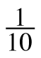. How many marbles that are not blue could he add to the bag so that the probability of choosing a blue marble becomes ?

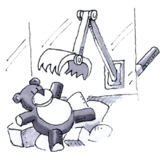
1-81. Your team is in charge of games at the CPM Amusement Park. One of the games involves a robotic arm that randomly grabs a stuffed animal out of a large bin. You need to set up the game so that the probability of a customer’s grabbing a teddy bear is exactly 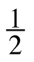.
a. How would you set up the bin? Explain.

b. What if you returned to check on the bin and found that there were 4 teddy bears left and 12 other animals? What could you add to or remove from the bin to return the probability of selecting a teddy bear to ?

1-82. Write four different fractions that are equal to 1. Use your calculator to check that you are correct.

1-83. A rectangular park is 150 yards on one side and 125 yards on the other.
a. If Debbie walks around the park two times, how far does she walk? Sketch a figure and show your work.

b. If Debbie wanted to walk 1,000,000 yards, how many times would she have to walk around the park?

1-84. Find the perimeter and area of each figure.
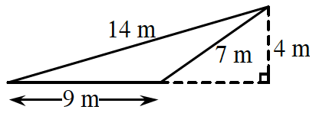
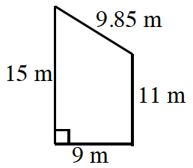
a. b.

Perimeter: _______________________ Perimeter: ___________________
Area: ________________ Area: ________________

